**Rossmoyne Senior High School Physics Unit 3 and 4 2021**

**Period Zero Test 3: Wave Particle Duality and the Quantum Theory**

**Name: __________________________________ Score: _________ /50**

**Time:** 45 min + 5 min reading

**Materials Provided:** This Question/Answer Booklet and the Formulae and Data Booklet

**Instructions:** When calculating numerical answers, show your working or reasoning clearly and include appropriate units. Give final answers to **three** significant figures. When estimating numerical answers, give final answers to a maximum of **two** significant figures.

1. Radar is used as a detection system relying on the production and detection of radio waves.
   1. A transmitter is a conductor of electrons that is used to produce the radio waves that propagate through the air. Describe how the transmitter is able to produce radio waves. [2 marks]
   2. The radio waves produced have a 15.0 × 102 MHz frequency. Calculate the wavelength of the radio wave. [2 marks]
   3. Describe the behaviour of electrons in the receiving antenna when interacting with the radio waves. [1 mark]
   4. Describe why the receiving antenna being surrounded by a curved dish helps with the detection of the radio waves. [2 marks]
2. The diagram shows a beam of **polarised** light being directed through a polariser into a photosensitive material behind. The photosensitive material records the intensity of the light reaching it.

Photosensitive material

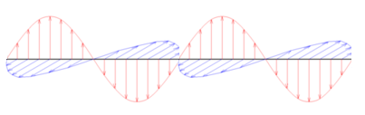

Polariser

* 1. Describe what polarised light is. [1 mark]
  2. The photosensitive material detects high intensity in the current arrangement shown in the diagram. The polariser is slowly rotated 1800 around an axis in line with the light’s velocity (as shown by curved arrow). Describe how the intensity of the light, as measured by the photosensitive material is affected during the rotation, if at all. [2 marks]
  3. Does the polarisation phenomena provide evidence light is a transverse or longitudinal wave? Describe how it supports one of these wave types but eliminates the other type. [3 marks]

1. Stars are incredibly hot and dense astronomical bodies that emit all wavelengths of electromagnetic radiation (from radio waves to gamma waves). The spectra of a red star and a blue star equidistant from Earth are shown below.
   1. By drawing a single arrow, and labelling it, identify which spectrum is for the red star. [1 mark]
   2. What physical property of stars, and black bodies in general, determines their colour? [1 mark]
   3. When the starlight is analysed by Earth based observatories, will an absorption or emission spectrum be viewed? Justify your choice. [2 marks]
2. The threshold wavelength for selenium used in a photoelectric experiment is 2.43 × 10-7 m.
   1. Define the meaning of a threshold wavelength within the context of the photoelectric experiment. [2 marks]
   2. Calculate the work function of selenium in electron volts. [4 marks]
3. The energy levels of an atom within the crystal matrix of a laser is shown below. This laser emits red light at a wavelength of 688 nm which is a product of one of the transitions as the electron falls from the n = 4 energy level.

n= $∞$

n= 6

n= 5

n= 4

n= 3

n= 2

n= 1

0 eV

-2.32 eV

-2.67 eV

-3.99 eV

-5.80 eV

-9.62 eV

-18.5 eV

* 1. What is the ionisation energy of this atom? [1 mark]
  2. **On the diagram,** draw in all possible transitions the electron may take as it returns to the ground state from the n = 4 energy level. [2 marks]
  3. Which transition is responsible for the emission of the red laser light? Use calculations to support your answer. [3 marks]
  4. Describe why an external energy source is required for the stimulated emission of the 688 nm laser light. [2 marks]

1. Rainbows reveal the true nature of white light. A collection of suspended water droplets in the air can have light incident upon them originating from the Sun. As the light moves from air to water it decreases its speed to 76.9% of its speed in air. The change in speed causes the light to change direction.

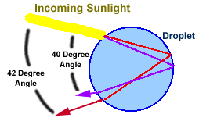

When the light reaches the back of the water droplet, it bounces off the boundary between water and air, returning to the front of the droplet. When the light leaves the front of the droplet, it changes speed and thus direction once more.

The trick to the formation of the rainbow is that each colour has its own unique speed in water. A different change in speed results in a different change in direction compared to other colours. Red is the fastest colour in water. It will have a different direction to violet, the slowest colour in water, after passing between the two mediums. This spreads the white light into all its colours.

* 1. Circle and clearly label one spot where refraction occurs in the diagram of the droplet. [1 mark]
  2. What is the name of the phenomena where white light is separated into its component colours? [1 mark]
  3. Determine both the frequency and wavelength of a 450 nm light wave once it has passed into water. [5 marks]

1. Light has a dual nature, seemingly able to behave as a wave under certain circumstances and as a particle under others.
2. State one experiment/situation where light is clearly behaving as a wave. [1 mark]
3. Describe what the observations of this experiment/situation are and briefly explain how the observations support wave behaviour. [3 marks]
4. State one experiment/situation where light is clearly behaving as a particle. [1 mark]
5. Describe what the observations of this experiment/situation are and briefly explain how the observations support particle behaviour. [3 marks]
6. Electrons are used in a double slit experiment, the setup and observations shown in the diagram below.

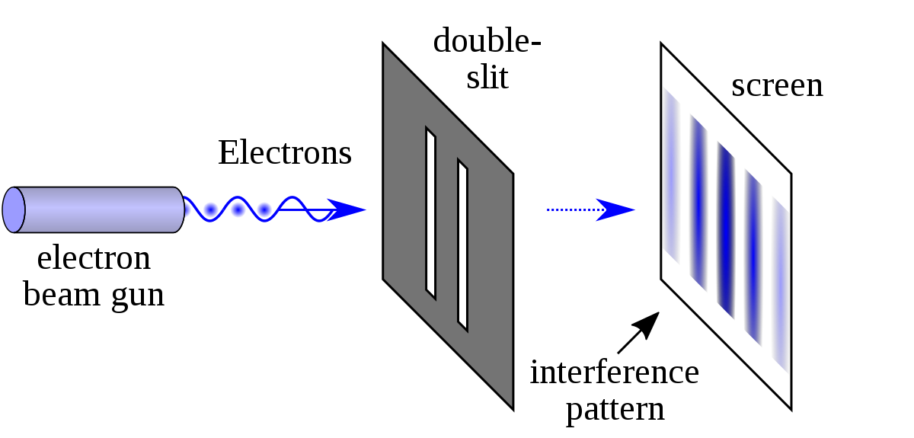

* 1. What does the interference pattern tell us about the nature of matter? [1 mark]

* 1. The electrons are fired from the electron beam gun at 3.86 × 105 m s-1. Calculate a suitable width of the slits to produce significant diffraction. [3 marks]

Slit width = _________________________ m

**END OF TEST**